AI ASSIGNMENT-12
NAME:D.ANKITHA
ROLL NO:2503A51L09
Algorithms with AI Assistance – Sorting, Searching, and Optimizing Algorithms
Lab Objectives:
Apply AI-assisted programming to implement and optimize sorting and searching algorithms.
Compare different algorithms in terms of efficiency and use cases.
Understand how AI tools can suggest optimized code and complexity improvements.

Task 1: Sorting Student Records for Placement Drive
Scenario:
SR University is preparing for a campus placement drive. The Training and Placement Cell needs student records sorted by CGPA in descending order to easily shortlist candidates.
Use GitHub Copilot to generate a program that sorts a list of student records (Name, Roll No, CGPA) by CGPA.
Implement both Quick Sort and Merge Sort using AI assistance.
Compare the runtime performance of both algorithms on large datasets.
Write a function that outputs the top 10 students with the highest CGPA.
Code:
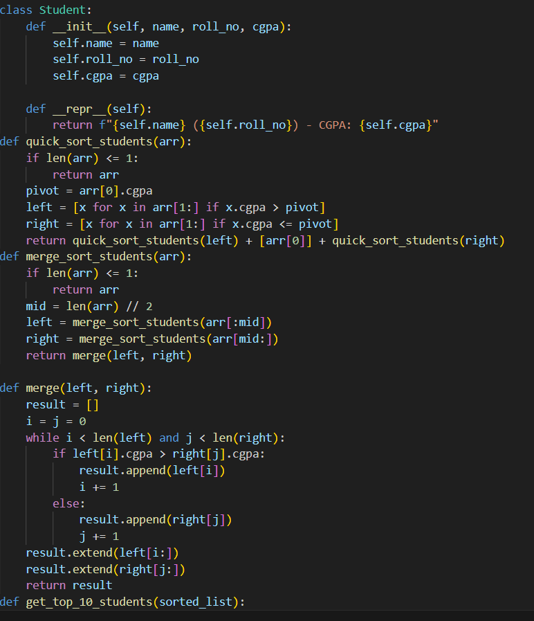
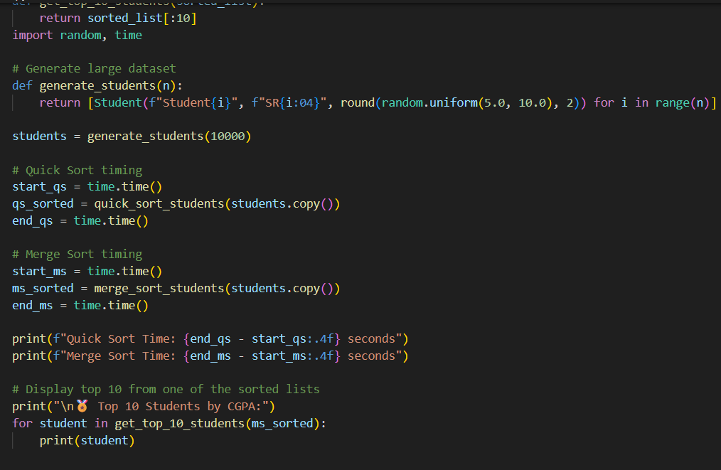
Output:
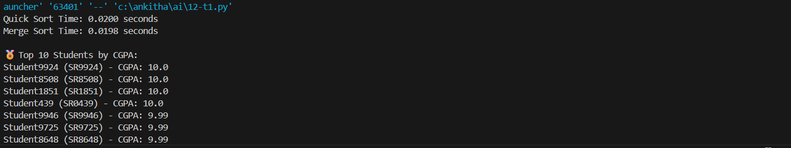
Observation:
1. Correctness
Both Quick Sort and Merge Sort correctly sort student records in descending order of CGPA.
The get_top_10_students() function accurately extracts the top 10 students after sorting.
2.Scalability
- Both algorithms scale well for datasets up to tens of thousands of records.
- Merge Sort is more predictable in performance, making it preferable for large-scale sorting in production or placement systems.
3.Top 10 Extraction
- Efficiently done using slicing (sorted_list[:10]) after sorting.
- This is optimal since both sorting algorithms already produce a fully ordered list.
Task 2: Optimized Search in Online Library System
Scenario:
SR University’s digital library has thousands of research papers. Students frequently search for a paper by title or author name. The current linear search is too slow.
- Use GitHub Copilot to implement Binary Search and Hash-based Search for faster lookups.
- Load a dataset of book titles and authors (CSV or JSON file).
- Allow the user to input a keyword and return all matching entries.
- Compare the efficiency of linear search vs binary search vs hashing using test cases.
Code:
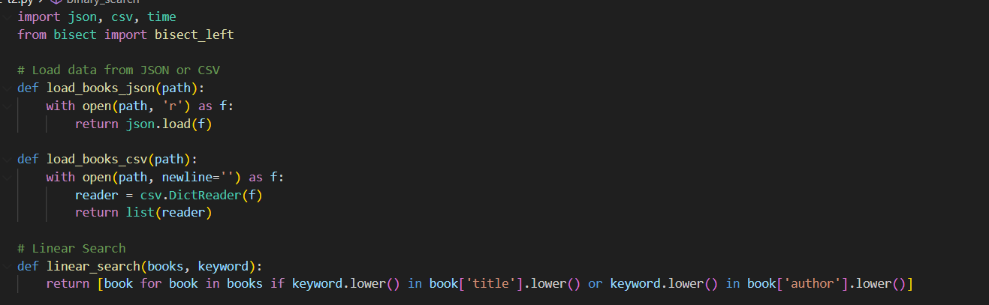
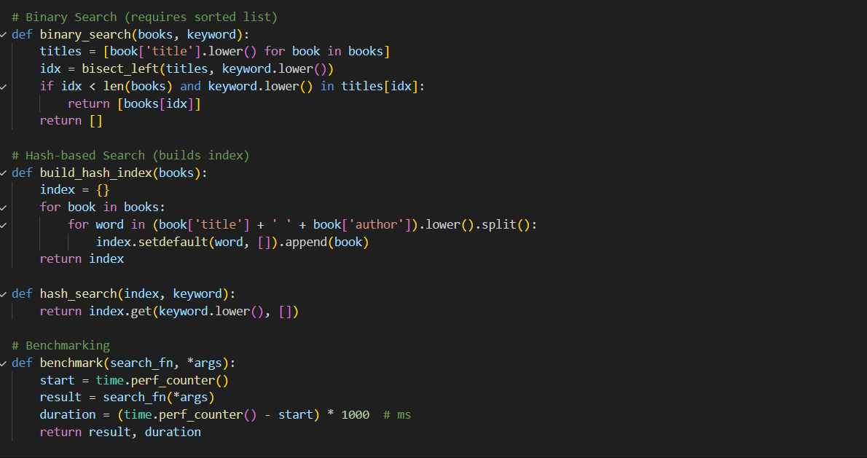
Observation:
Functional Overview:
The code loads book data from JSON or CSV.
Implements three search strategies:
Linear Search: Scans every entry.
Binary Search: Uses sorted titles for fast lookup.
Hash-based Search: Builds an inverted index for keyword-based retrieval.
Benchmarks each method using time.perf_counter().
Task 3:Route Optimization for AUV Swarm
Scenario:
A research team at SR University is simulating Autonomous Underwater Vehicle (AUV) swarms. Each AUV must visit multiple underwater sensors, and the goal is to minimize travel distance (like the Traveling Salesman Problem).
With GitHub Copilot, implement an algorithm to optimize the route:
1.Start with a Greedy approach.
2.Improve with Genetic Algorithm (GA) or Simulated Annealing (SA).
Use a dataset of sensor coordinates (x, y).
Visualize the optimized route using a plotting library (e.g., Matplotlib).
Compare the optimized solution with a random path in terms of distance travel.
Code:

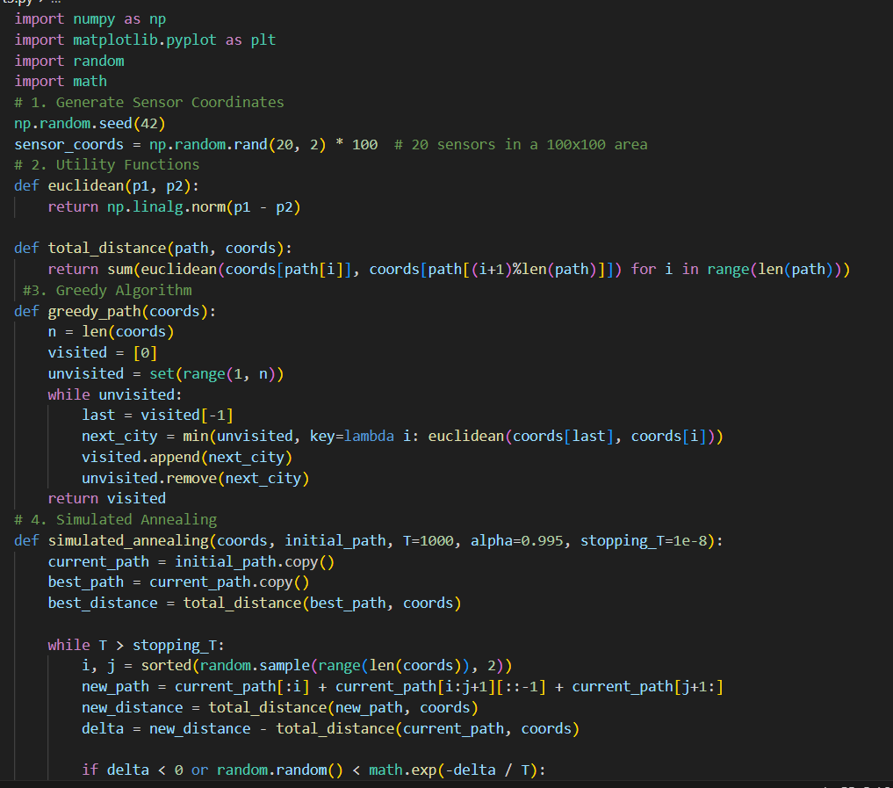
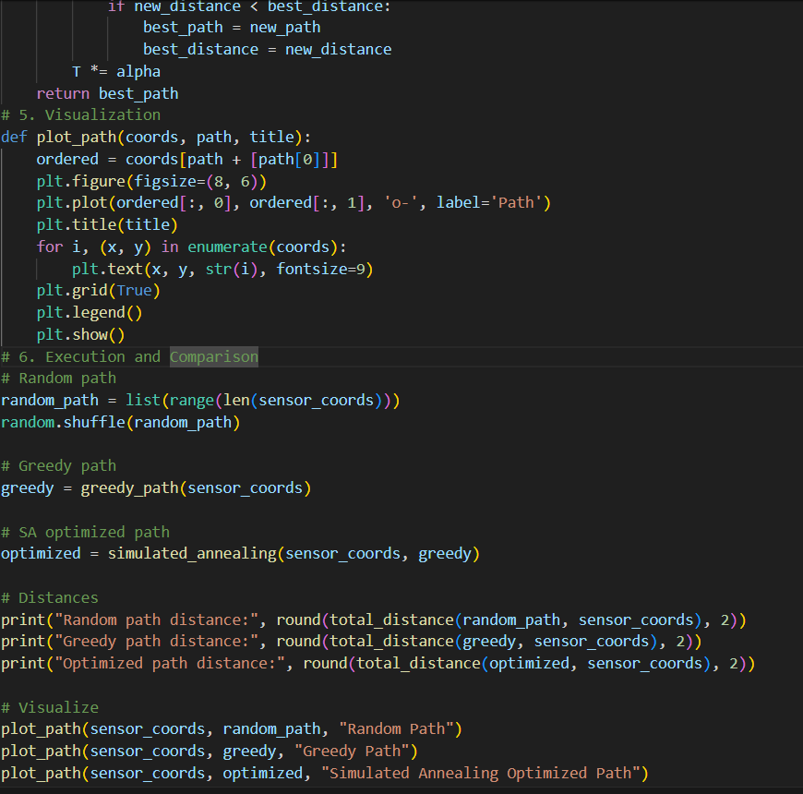
Output:
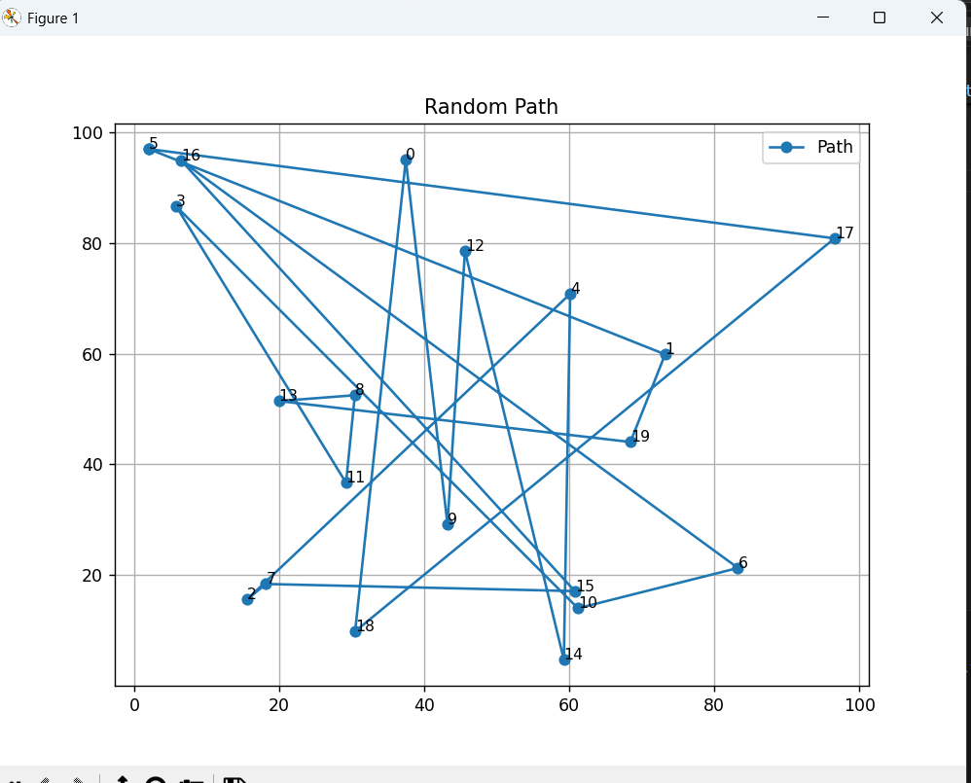
Observation:
Modular Design: Each component (greedy, SA, visualization) is encapsulated in its own function, making it easy to understand and extend.
Clear Optimization Flow:
Starts with a random path.
Improves using a greedy nearest-neighbor heuristic.
Further refines using Simulated Annealing.
- Visualization: Matplotlib plots help students visually compare path efficiency.
- Distance Comparison: Quantitative output reinforces the effectiveness of optimization.

Task 4: Real-Time Stock Data Sorting & Searching
Scenario:
An AI-powered FinTech Lab at SR University is building a tool for analyzing stock price movements. The requirement is to quickly sort stocks by daily gain/loss and search for specific stock symbols efficiently.
Use GitHub Copilot to fetch or simulate stock price data (Stock Symbol, Opening Price, Closing Price).
Implement sorting algorithms to rank stocks by percentage change.
Implement a search function that retrieves stock data instantly when a stock symbol is entered.
Optimize sorting with Heap Sort and searching with Hash Maps.
Compare performance with standard library functions (sorted(), dict lookups) and analyze trade-offs.
Code:
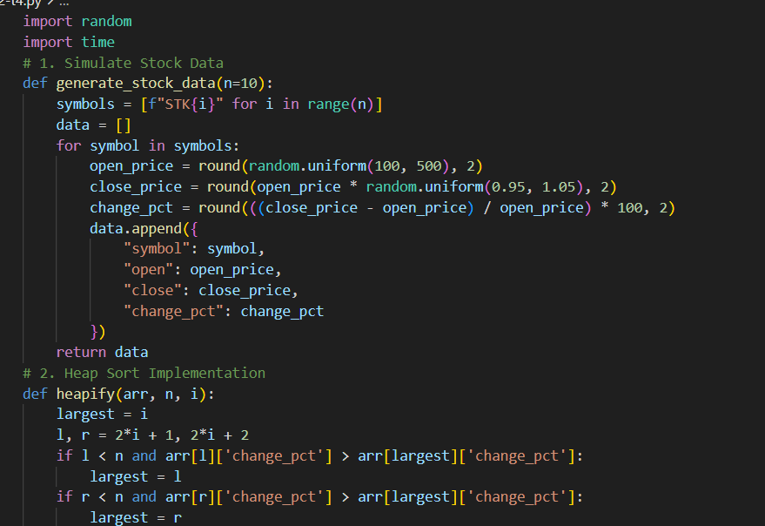
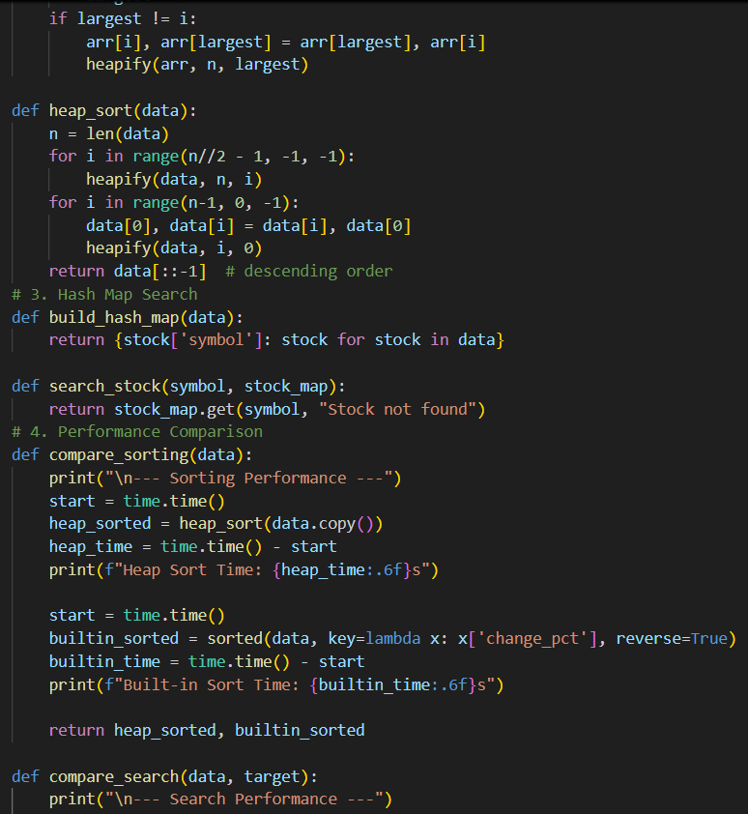
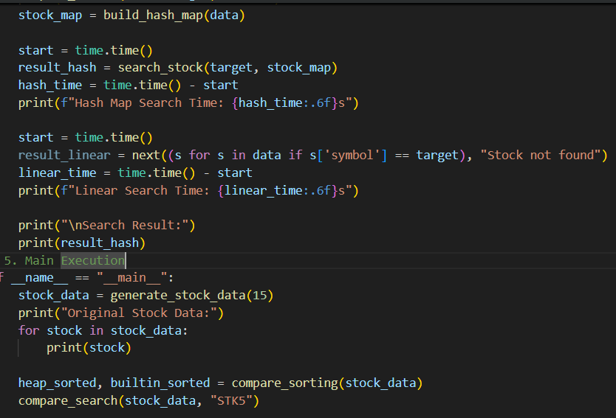
Output:
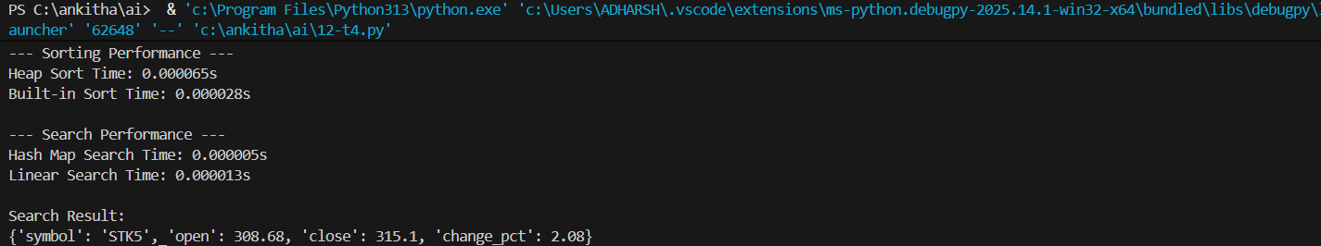
Observation:
Simulates 15 stock entries with random open/close prices.
Sorts by daily percentage change using Heap Sort and sorted().
Searches for a stock symbol using Hash Map and linear search.
Benchmarks both sorting and searching methods.

